Home page correction
1) To check with Integrity logo on four principals
2) To Change Pera Content of “How We Handle Your Data”
Correct one: We access your systems securely, with appropriate controls in place to protect client information throughout the engagement.
3) Remove double logo of Xero on “Certified on the platforms you already use”
4) Getting Started is simple just add “an” article before “a”
Correct One: we offer a risk-free 20-hour trial after signing an NDA.
5) Software behind our outsourced solution solutions fix logo size on tax preparation for “UltraTax CS” and “Intuit ProConnect”
Company Overview
1) Remove content from “Who We Are”. Find correct one
Correct One: “Beyond Outsourcing: More Than Just Another Service Provider
2) Our Pathway to excellence – Please checked with old website and apply here
3) Content of Our vision and Our Mission should be same as home page please apply here
4) Change Ehjaz Headshot updated one has been shared on what’s app
5) Fix Experienced and Cross border size
6) Software Stack behind our outsourced solutions: Takes all software from home page by each service and keep as it is. Also remove Pera content as well
Why Choose us
1) Please apply content here which I shared with you with flip concept.
2) Fix Pathway to excellence here as well
3) Add those testimonials for both countries which I shared
Data Security
1) Just wanted to be changed Pera Content
Correction one: We access your systems securely, with appropriate controls in place to protect client information throughout the engagement.
2) Here entire content has been changed please refer old website for the same

Services
Bookkeeping:
1) Main Content Correction: “Outsourced bookkeeping services for businesses.
2) Pera Content Correction: “Outsourced bookkeeping for ambitious businesses across the USA and Australia. We record every transaction, reconcile every account, and close your books by the 10th of each month, with a second review for accuracy and give you transparent flat monthly fees.”
3) Please only shows logo here for “Software for Outsourced Solutions”. Remove “Pronto” Software from here
4) Comparison Table:
 | In-House Bookkeeper | With QuantBooks
Cost | Annual salary, employer payroll taxes, benefits, and software costs. | One flat monthly fee based on your transaction volume.
Time To Start | Recruiting, interviewing, and training can take four to eight weeks. | Get started within 48 hours once the scope and access are finalized.
Time Off | Bookkeeping may fall behind during vacations, sick leave, or staff transitions. | Team-based support helps keep your books moving, even when someone is unavailable.
Skill Range | The quality and range of support depend on one person's experience. | Bookkeeping, review, and accounting oversight are included in one fee.
Software | You manage the software subscriptions, licenses, and related costs. | We work in the file you already own.
Growth | Higher transaction volumes may mean overtime or hiring additional staff. | Bookkeeping support can expand as your transaction volume and business needs grow.

5) Changes in how to get started in second number point
1) “We set up secure, restricted access to your accounting software, align your chart of accounts with your reporting needs, and agree on a clear monthly fee.”
2) Remove this line from point number four: “, 100% CPA-ready.”
6) Correction in Testimonial’s
Remove Pera content from here and put business owner only testimonials from US and AUS. Please find my first file for the same name “Content for Website”
7) Correction in FAQ’s
Q-1) How much do outsourced bookkeeping services cost for business?
A-5) Most clients are ready to get started within 48 hours. We begin with a discovery call to understand your requirements, followed by a written scope of work and a fixed-fee agreement. Once the agreement is signed and the NDA is in place, we begin onboarding. However, more complex bookkeeping requirements may take longer. If your engagement requires additional time, we’ll discuss the expected timeline with you during the initial call.
8) Correction in Inquiry Page
Remove free trail from here and every page of services.
Note:
Need to change and checked figure and layout of live dashboard of amounts on home page of bookkeeping
Remove below
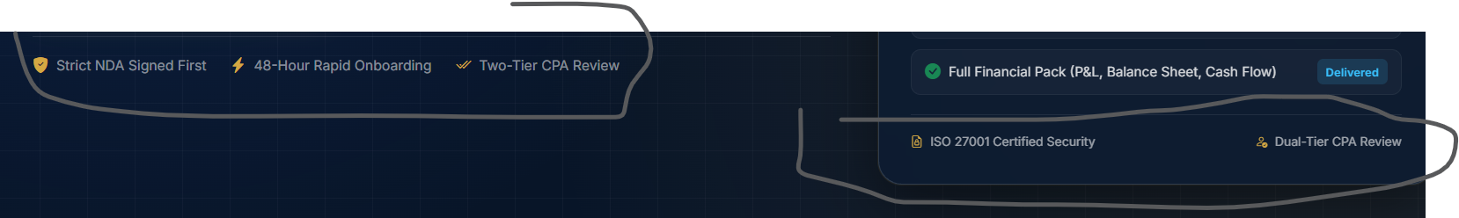
Clean up and catch-up services
1) Main Content Correction: “Bookkeeping Cleanup and Catch-Up Services to Get Your Books Back on Track”
2) Pera Content Correction: “We help businesses get their books back in order, whether they’re a few months or several years behind. Our team reviews and categorizes transactions, reconciles accounts, and corrects discrepancies to bring your financial records up to date. You’ll receive organized books along with a record of the adjustments made. Every project includes an agreed-upon scope, a flat fee, and a clear timeline, with most projects completed within 3–15 business days.”
3) Pera Content for what cover catch up services: “Every business has different bookkeeping needs, especially when records are incomplete or overdue. To help you understand what to expect, here’s what our bookkeeping catch-up and cleanup service covers, step by step.”
4) Comparison Table Pera Content: “The longer your books stay behind, the harder it gets to catch up.”
5) Comparison Table:
 | Without Cleanup | With QuantBooks
Scope | The backlog grows with every passing month | A clear plan to bring your books up to date
Tax Preparation | Incomplete books can delay tax preparation | Organized records ready for your CPA’s review
Records | Older statements become harder to retrieve | We gather available records and flag missing items
Deduction | Uncoded transactions can lead to missed deductions | Expenses categorized for your CPA to review
Finance | Outdated financials can complicate loan applications | Updated books make financial information easier to share
Cost of the fix | More delays can mean more cleanup work | Scope and fees agreed before work begins

6) Software for outsourced solutions: Remove pronto from here
7) Changed correction on how to get started please find below
Second point: You get a clear scope of work, one fixed fee, and an agreed finish date. If a tax deadline is approaching, we confirm the timeline is realistic before getting started.
8) FAQs correction
Answer no 1: Bookkeeping clean up services are priced as one flat project fee, based on the size of the backlog, not billed by the hour. Two things drive the fee: how many months are open and how many accounts need reconciling. We quote after a free look at your actual file. The fee is fixed, so it holds even if the work turns out messier than it looked.
Answer No 2: Remove this line “We provide a guaranteed completion date in your written proposal”
Answer No 3 Correction: There is no limit on how far behind the books can be. We often take on files two or three years behind, files a past bookkeeper left mid-year, and businesses bought with no usable records. The IRS generally expects you to keep records for at least three years, so older gaps can still matter at tax time.
Answer No 4 Correction: Catch-up fills in work that was never done, while clean up fixes work that was done wrong. In a catch-up, months of transactions sit uncoded and unreconciled. In a clean-up, entries exist but are miscoded, doubled or unreconciled, so the reports cannot be trusted. Most real files need both, so we quote clean up and catch-up bookkeeping services as one project.
Answer No 5 Correction: Yes, we can fix messy books for taxes as long as the deadline is realistic, and we confirm that before you commit. Tell us the date on the first call. If we cannot make it, we will say so rather than take the work and miss. Your CPA can then file an extension; such as Form 7004 for a business return. An extension moves the filing date, not the date tax is due
9) Changed content for Inquire page for Main content. Remove free trail
Correction: “Get a clear picture of your backlog”
Sales Tax and Payroll
1) Main Content Correction: Outsourced Sales Tax and Payroll Compliance That Keeps You Stress-Free
2) Pera Content Correction: A single place to handle all your multistate sales tax obligations and payroll compliance without missing any deadlines or incurring costly penalties.
3) We need to changed main content for what we are offering. In this page we have two service together so I bifurcated into two to better showcase.
Main Content: “Sales tax compliance that keeps your business on track “
Pera Content: End-to-end sales tax management across state registrations, nexus, filings, and ongoing compliance.
Now what we are covering into these services please find snip for the same
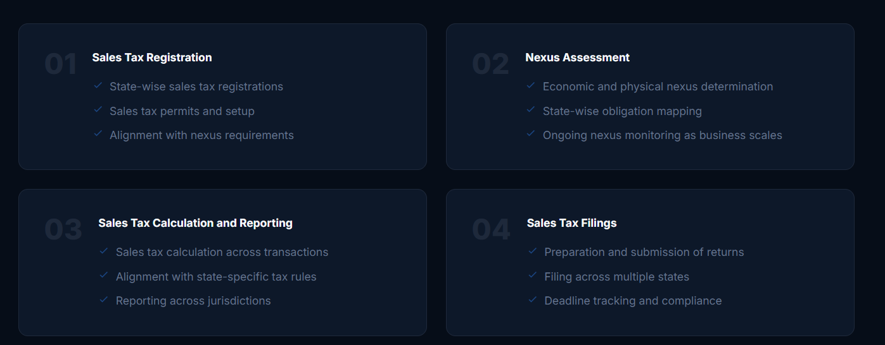
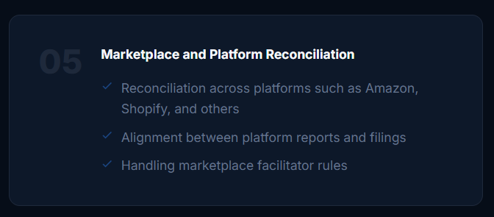
Payroll:
4) Main Content of Payroll: “Payroll services that keep you stress-free”
5) Pera Content: End-to-end payroll and employment tax management across all US business structure
Now what we are covering into these services please find snip for the same
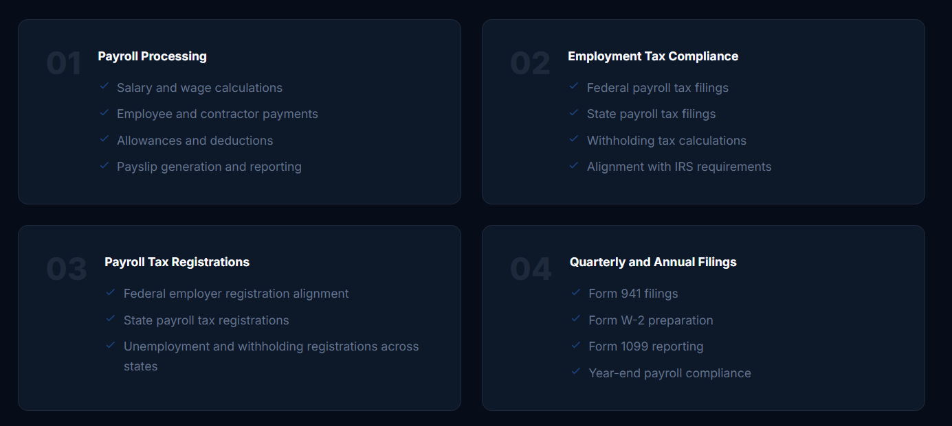
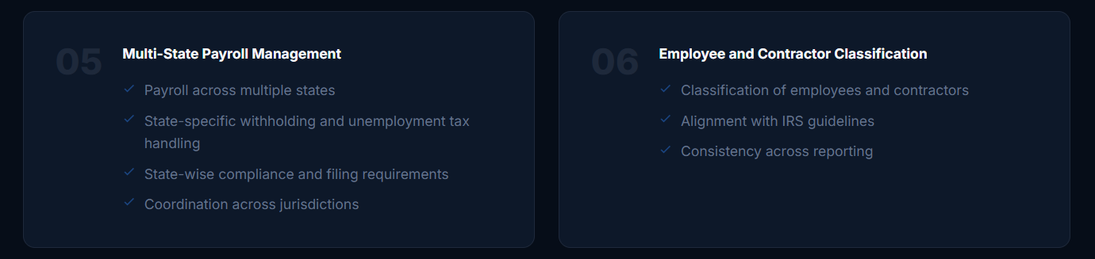
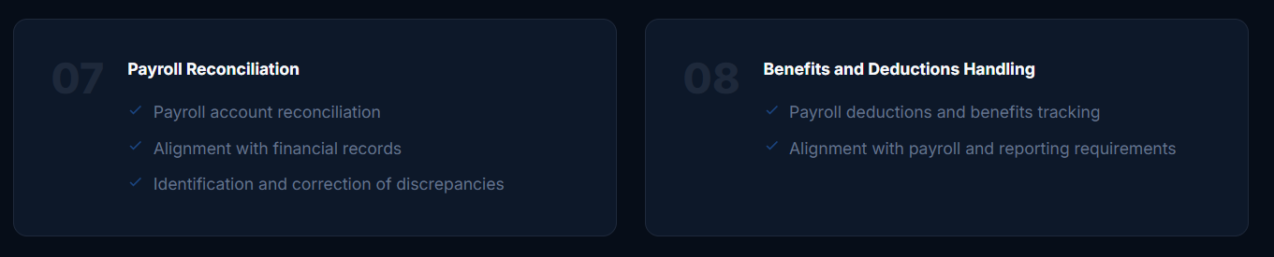
6) Comparison table:
 | Do it yourself | With QuantBooks
Regulatory Expertise | Internal staff struggle to stay up to date with compliance requirements across all 50 states. | We keep your filings on schedule and aligned with applicable state requirements.
Multi-State Compliance | New sales or employees in another state can create unexpected filing obligations. | From registration to filing, every step stays up to date.
Software Costs | Separate software subscriptions and add-ons can increase costs. | We work within your existing systems wherever supported.
Deadlines & Penalties | Missed deadlines and filing errors can lead to costly penalties and notices. | From manage filings Calanders to compliance schedules we keep track of everything.
Payroll Support | Paycheck questions, employee updates, and year-end forms take time. | Payroll processes run smoothly, and employee records stay organized.
Growth | Expanding into new states means more registrations and filings to handle. | As your business grows, we help you manage additional compliance requirements.

7) Changes in how to get started:
Point No 2 correction: We work within your existing payroll and sales tax systems and coordinate payroll calendars and tax filing schedules.
8) Client endorsement
Main Content: “What our client says”. Pera content removes from here. Remove those things which I have highlighted in red. Also changed little bit of testimonials “A friend referred me to Ehjaz”
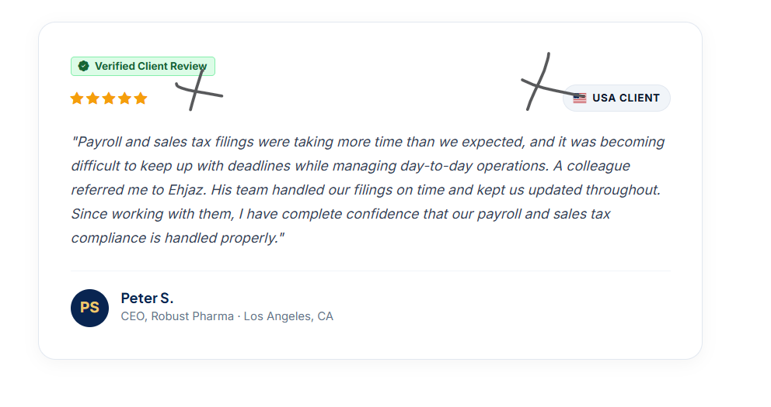
9) FAQs Correction
Ans No 1: Remove this line “and municipal taxing districts”. And add full stop after 50 U.S states.
Ans No 2 Correction: “We work directly in your existing payroll platforms, including Gusto, ADP, Paychex, QuickBooks Payroll, and Square Payroll, as well as sales tax platforms such as Avalara, TaxJar, and Vertex. We also record payroll summary journal entries in your QuickBooks or Xero accounting software to keep your financial records up to date.
Remove entire Question no 3
Answer 4 corrections: We take care of the registration and setup needed when your business expands into a new state. This includes registering for state withholding and unemployment taxes, updating your payroll system with the correct tax rates, and making sure your sales tax permits are in place.
Answer 5 correction: We follow ISO 27001:2022-certified security controls, with encrypted data transfers, restricted user access, and confidentiality agreements in place.
Remove 20 hours free trail from here
Tax Preparation and Filing:
1) Main Content Correction: “Outsourced Tax Preparation and Filing Starts with Organized Books”
2) Pera Content: “Tax preparation from books that already reconcile. We prepare federal and state returns, review them with you and e-file in all 50 states. One flat fee by entity and complexity, quoted before work starts.
3) Pera Content for tax services covers: “Here’s what’s included in our outsourced tax preparation service. We focus on getting your tax returns prepared accurately and filed on time, without unnecessary extra or hidden cost”.
Now I have changed what services covers in tax preparation please find them below: Reference I have taken from: https://www.twelixaccounting.com/tax-preparation-filing-services

1. Returns  Federal and state return prepared and filed accurately, based on your financial records.  Business tax returns  Schedule C, single and multi-member LLCs, Form 1065 partnerships and Form 1120-S S corporations.  Individual tax returns  Form 1040 preparation for individuals and business owners.  Partner and shareholder K-1s  K-1s prepared alongside partnership and S corporation returns. | 2. Through the year  Recurring tax filings and payment deadlines managed throughout the year.  Quarterly estimated taxes  Estimated payments calculated using current-year financial information.  1099 preparation  Contractor details and W-9s organized for timely 1099 filing preparation | 3. Before and After  Supporting records reviewed and outstanding tax filing issues addressed.  Deduction review  Business expenses reviewed for potentially deductible costs.  Tax workpapers  Supporting schedules and documents organized for tax reporting.  Prior-year and catch-up returns  Outstanding returns prepared using available prior-year records.  IRS and state notice support  Help reviewing notices and gathering supporting documents.

4) Specialized tax stack:
Main Content Correction: We work inside the tools you already use.
Pera Content Correction: No forced migrations and no proprietary portal. We plug into your existing stack, or help you pick the right one during onboarding.
Can you please adjust logo size of UltraTax CS and Intuit Pro Connect
5) Comparison table:
Pera Content Correction: “Every return follows the same rules and deadlines, but the records, calculations, and preparation behind each one can look very different.
Please find correction in comparison table

 | Filing from a shoebox | With QuantBooks
Starting point | Records that need sorting before tax work can begin | Books kept up to date and ready for tax preparation
Deductions | Expenses reviewed at year-end, when some details may be missing | Expenses recorded throughout the year and reviewed before filing
Estimated taxes | Payments based largely on last year's figures | Payments calculated using current business figures
Timeline | Delays while records and missing documents are collected | Less back-and-forth when records are already organized
State filings | State filing obligations discovered late | State requirements tracked as the business grows
Cost | Extra work, rush fees, and possible penalties | Fees agreed upon upfront, before work begins

6) Testimonials:
Main Content Correction: What our client says
Remove Pera Content from here and now find two new testimonials
I switched to Ehjaz this year, and he made the whole process really easy. He handled both my S-Corp and individual tax returns, kept me informed throughout, and made sure everything was filed on time without any penalties. He was thorough, communicated clearly, and was great to work with. I’d definitely recommend him!
Ross T.
Managing Member, Apex Consulting LLC · Austin, TX
As a first-time business owner, I had no idea where to start with taxes, but Ehjaz and his team made the process seamless. They patiently answered all my questions, explained everything in a way I could understand and I felt supported throughout the process. They handled my taxes efficiently and also helped me get my messy books back on track. I highly recommend Ehjaz and his team!
Chelsay R.
Owner, Blue Shield LLC – Stillwater, MN
7) FAQs correction
Ans 1: We charge a single, upfront flat fee for tax preparation based on your business entity structure and the complexity of your tax return. We never bill by the hour. You’ll receive a written quote within 24 hours of our consultation call, and that’s the exact amount you’ll pay.
Ans 2: We do both: our tax preparer prepares the return, walks you through it line by line for your review and approval, and then electronically files it directly with the IRS. Nothing is submitted without your signed authorization, and you receive electronic confirmation of the filing.
Ans 3 : We handle Form 1040 individual returns and business returns for most small entity types. That covers sole proprietors on Schedule C, LLCs, partnerships on Form 1065 and S corporations on Form 1120-S. It includes the K-1s that go to each partner or shareholder.
Ans 4 : We prepare past-due returns oldest year first, so each one builds on a correct prior year. Where the books for those years are incomplete, we scope the bookkeeping catch-up first. A return filed from rebuilt guesses is worse than a late one filed from real records. Penalty relief and IRS payment plans are best discussed with a CPA or enrolled agent.
Q 5: Can I do my own business taxes?
Ans: Yes, you can legally prepare your own business return, and many sole proprietors do with software. It gets harder with an S corporation, a partnership, payroll or sales in several states. Those bring K-1s, state filings and basis tracking, a running record of each owner's investment, that software will not check for you. If your books are not reconciled, the return carries their errors either way.
8) Inquiry page content correction
Main Content Correction: Get a number before the season starts.
Pera Content: Start with a free tax consultation. We will confirm which returns you owe and where, look at the state of your books, and send a flat quote within 24 hours.
Remove 20-hour free trail from here.
Industries
In New link main content and Pera content is good but remove those things which I have heighted below.

Apply all industries concept from old website and copy here.
Apply all software by services here
Then remove below highlighted things


Changed CTA from Request a free trail to “Talk to us”
No changed in FAQ but yeah second review is pending from Ehjaz bhai but I can say no major changes will occur
Special Notes:
1) Remove 20 hours free trail from each service for B2C and apply CTA of “Talk to us”
2) When there is a CTA button of book a free consultation will add Google meet or Calendly link
3) I was not able to find to fic virtual CFO but I am trying and digging into this meanwhile you can continue with these correction
4) For CPA firms content please find below website to design and drafting: https://wachstumkpo.com/outsource-bookkeeping-services/#
5) Remove Pera Content from below image for all services

6) CPA firm for each service should be draft and follow same sequence like Services

